Unit:01 NATURE OF SCIENCE IN BIOLOGY

All Lectures Uploaded on YouTube: (New Link with Ayesha)

Q. What does Biology mean?
Ans. The word "biology" comes from the Greek words "bios," meaning "life," and "logia," meaning "study of." So, biology literally means "the study of life."
It is the Branch of science which studies living things and how they interact with each other and their environment.

Major Divisions Of Biology:

- Zoology: This division studies animals. The word "zoology" comes from two Greek words: "zoon," meaning animal, and "logos," meaning study.

- Botany: This is for studying plants. The word "botany" comes from the Greek word "botanē," which means plant.

- Microbiology: This branch studies organisms that are too small to see without a microscope, like bacteria and viruses. The word "microbiology" comes from two parts: "micro," meaning small, and "biology," meaning the study of life

BRANCHES OF BIOLOGY:

For your exam, you need to know 3 things about each of the branches of biology: Definition, Example and Word Origin.

Morphology: It is the study of the shape, size, and structure of living things like animals, plants, and microorganisms.
Example: Looking at the structure of a flower, like its roots, stem, and leaves. Word origin: "Morpho" (Greek) means form or shape, and "logy" means the study of.

Anatomy: It studies the internal parts of living things, like the heart, brain, and muscles in humans and animals.
Example: Studying how the human body is organized inside.
Word origin: "Ana" (Greek) means up, and "tomy" means cutting, referring to cutting or dissecting to study the structure.

Physiology: It deals with how the different parts of living organisms work and their functions.
Example: Studying how the heart pumps blood.
Word origin: "Physio" (Greek) means nature, and "logy" means study.

Histology: This is the study of tissues, which are groups of similar cells that work together to do specific jobs.
Example: Studying epithelial tissue, which covers and protects surfaces like the skin.
Word origin: "Histo" (Greek) means tissue, and "logy" means study.

Cytology: It is the study of cells, the smallest living units of organisms. Example: Looking at plant and animal cells under a microscope.
Word origin: "Cyto" (Greek) means cell, and "logy" means study.

Genetics: This field deals with genes and how traits, like eye color or flower color, are passed from parents to their offspring.
Example: Learning how genes control whether flowers are red or white. Word origin: "Gen" (Greek) means birth or origin.

Molecular Biology: This is the study of the molecules that make up living things, like DNA and proteins.
Example: Understanding how DNA carries genetic information.
Word origin: "Molecule" (Latin) means little mass or substance, and "biology" means the study of life.

Embryology: It studies how organisms develop from a fertilized egg into a complete being.

Example: Observing how a human embryo develops inside the mother’s womb.
Word origin: "Embryo" (Greek) means developing offspring, and "logy" means study.

Paleontology: It deals with the study of fossils and ancient life forms that lived millions of years ago.
Example: Studying dinosaur fossils.
Word origin: "Paleo" (Greek) means ancient, and "ontology" means study of Being. (Fossils mean “the remains of organisms”)

Taxonomy: It is the classification and naming of organisms.
Example: Naming and grouping animals like classifying humans as Homo sapiens.
Word origin: "Taxis" (Greek) means arrangement, and "nomy" means law or method.

Ecology: It is the study of how living things interact with each other and their environment.
Example: Studying how animals in a forest depend on plants for food. Word origin: "Eco" (Greek) means house or environment, and "logy" means study.

Marine Biology: It studies organisms that live in the ocean.
Example: Studying sea creatures like whales, coral reefs, and jellyfish. Word origin: "Marine" (Latin) means sea, and "biology" means study of life.

Pathology: It is the study of diseases, how they develop, and how they affect the body.
Example: Studying how a virus causes illness.
Word origin: "Pathos" (Greek) means suffering or disease, and "logy" means study.

Immunology: It is the study of the body’s immune system and how it protects against diseases.
Example: Learning how vaccines help the body fight viruses.
Word origin: "Immunis" (Latin) means safe or free from, and "logy" means study.

Pharmacology: It is the study of drugs and how they interact with the body to treat diseases.
Example: Researching how aspirin reduces pain.
Word origin: "Pharmakon" (Greek) means drug or medicine or poison, and "logy" means study. (small amounts of poison can be used to treat various diseases.)

Home Work
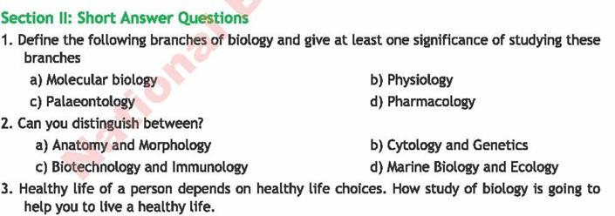

Answer all the questions after thoroughly understanding the concepts from the first lecture. I hope you grasp everything well.
GOOD LUCK!!!















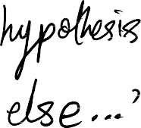






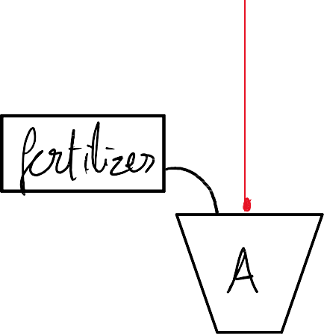
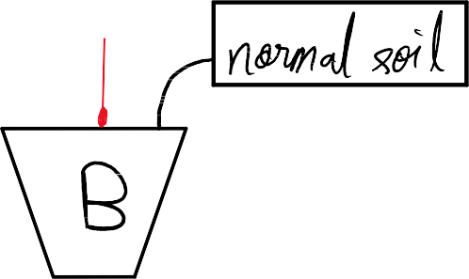












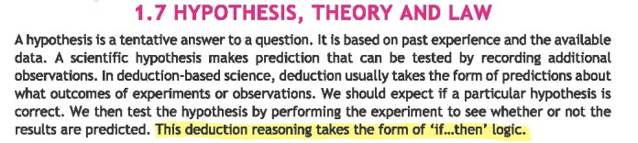
Supplementary Notes:




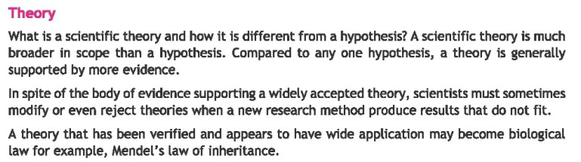
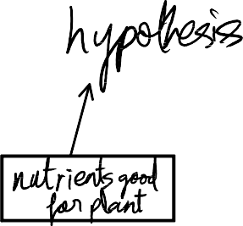
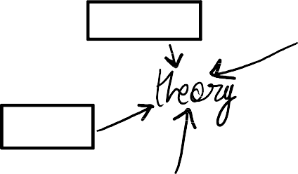



















Revision: Unit 1

Multiple Choice Questions:
1. C
2. B
3. C
4. A
5. D
6. C
7. C
8. B
9. A
10. A
11. D
12. B
13. B
14. C

Short Answer Questions:

Q.1)

Molecular Biology
- Definition: Molecular biology is the study of biological activity at a molecular level. It focuses on the interactions and relationships between the various systems of a cell, including the interrelationships of DNA, RNA, and protein synthesis and how these interactions are regulated.
- Significance: Molecular biology has revolutionised our understanding of life processes. It has led to significant advancements in fields like medicine, agriculture, and biotechnology. For example, it has enabled the development of gene therapies, the creation of genetically modified organisms, and the understanding of genetic diseases.

B. Physiology
- Definition: Physiology is the study of the functions of living organisms and their parts. It deals with the mechanical, physical, and biochemical functions of organisms, as well as the ways in which these functions are maintained.
- Significance: Physiology is crucial for understanding how organisms function, adapt to their environments, and maintain homeostasis. It has applications in various fields, including medicine, where it helps us understand how diseases affect the body and develop treatments. It also plays a vital role in fields like sports science and exercise physiology.

C. Paleontology
- Definition: Paleontology is the scientific study of prehistoric life forms on Earth through the examination of fossils. It provides insights into the history of life on Earth, including the evolution of organisms and the changes in Earth's environment over time.
- Significance: Paleontology is essential for understanding the history of life on Earth and the processes of evolution and extinction. It helps us to reconstruct past ecosystems, understand the impact of climate change on life, and predict future environmental changes.

D. Pharmacology
- Definition: Pharmacology is the study of drugs and their interactions with living systems. It encompasses various aspects, including drug discovery, design, action, and safety.
Significance: Pharmacology is crucial for the development and use of medicines. It helps us to understand how drugs work, their side effects, and how to use them safely and effectively. Pharmacology plays a vital role in improving human health and well-being.

Q.2)

Anatomy vs Morphology
Anatomy focuses on the internal structures of organisms, their arrangement, and their relationships. Meanwhile, morphology studies the external and internal structures of organisms as a whole, including their form, shape, and size.

Cytology and Genetics
Cytology studies cells, their structure, function, and organisation and examines cellular components like organelles, membranes, and the cell cycle. Whereas, genetics is the study of genes, heredity and genetic variation in organisms. It focuses on DNA, RNA and chromosomes and how genetic information is passed down from generations

Biotechnology and Immunology:
Biotechnology is the use of living organisms and their components to develop products for various purposes, including genetic engineering etc. Immunology, on the other hand, is the study of the immune system, which protects the body from diseases.

Marine Biology and Ecology
Marine Biology is the scientific study of organisms that live in the ocean and their interactions with the marine environment. Ecology, however, examines how organisms interact with each other (e.g., predation, competition) and how they are influenced by abiotic factors (e.g., temperature, sunlight, water).

Q.3)
Biology empowers us to live healthier lives by providing crucial knowledge about the human body, disease prevention, and the impact of our environment on our well-being. Understanding how our bodies function, the importance of nutrition and exercise, and the causes and spread of diseases allows us to make informed choices about our health and take proactive steps towards a healthier lifestyle.

Q.4)
A.F.A. King worked on mosquitos and malaria
Ronald Ross discovered the transmission of malaria
Laveran discovered that a single-celled organism causes malaria

Q.5)
Colour of cat– qualitative, Height of giraffe– quantitative Weight of mango– quantitative
Body temperature of birds– quantitative Volume of blood– quantitative
Shape of leaves– qualitative
The climate of the desert– qualitative Speed of tiger– quantitative
Song of a Bird— qualitative
Q.6) yes, the hypothesis given by a Nobel prize winner can be wrong since the hypotheses are made on limited evidence and without investigation. The reasons it may be wrong are; incomplete or insufficient data as then the hypothesis would not be generalisable in broader contexts. The methodologies could also be wrong or have errors in sampling and data collection. The deductions that can be made from this hypothesis are: 1) Reducing the severity of disease is one of the outcomes of a successful immune response. 2) Clinical trials have shown that COVID-19 vaccines reduce hospitalisation and severe cases.

Q.7)
Eradicating malaria would be incredibly challenging and near to impossible. The Plasmodium parasite that causes malaria has a complex life cycle, involving both human and mosquito hosts. This makes it difficult to target and eliminate all stages of the parasite. Mosquitoes have developed resistance to many insecticides and anti-malarial drugs, making it harder to control their populations. In many malaria-endemic regions, access to healthcare and effective malaria prevention and treatment tools is limited.
Moreover, any vaccine hasn’t yet been found 100% effective for it to work with complete efficacy

Q.8)
- The term "vector" is used for mosquitoes because they are organisms that transmit pathogens from one host to another. In the case of malaria, mosquitoes (Anopheles) act as vectors by carrying the Plasmodium parasite from an infected individual to a healthy one, facilitating the spread of the disease.
- The Plasmodium species is the parasite responsible for malaria. In humans, the main species are Plasmodium falciparum, Plasmodium vivax, Plasmodium malariae, and Plasmodium ovale. In birds, Plasmodium relictum is a common species that causes avian malaria.
- Ronald Ross aimed to demonstrate the role of mosquitoes in the transmission of malaria. His experiments were designed to prove that mosquitoes are the vectors that carry the Plasmodium parasites, completing the parasite's life cycle and transmitting it to humans.

Q.9)
Ross did not allow infected mosquitoes to bite healthy person to prevent the transmission of malaria to humans and to ethically conduct the experiment by avoiding harm to humans. His goal was to study the transmission of malaria, and he conducted his research with strict scientific and moral responsibility. Letting an infected mosquito bite a healthy human could have led to serious illness or death, especially since there were no effective treatments for malaria at the time. Instead, Ross used bird models and experimental controls to prove that malarial parasites are transmitted through the bite of female Anopheles mosquitoes, making a major breakthrough in medical science without putting human lives at unnecessary risk.

Q.10)
Hepatitis B virus (HBV) was found in the blood of 10 persons, but only 6 of them were suffering from the disease because the presence of the virus does not always mean active illness. Some individuals may be carriers of the virus—they have the virus in their blood but do not show symptoms or suffer from the disease because their immune system is keeping the virus
under control. Others may be in the incubation period (infected but not yet showing symptoms) or may have developed immunity after a past infection or vaccination. This shows that infection and disease are not always the same—a person can be infected (virus present) without being diseased (no symptoms or organ damage).

Extensive Answer Questions:

Q.1)
Biology is deeply interconnected with other branches of science, making it an interdisciplinary field. It links with chemistry through biochemistry, where understanding the chemical composition of cells, enzymes, and hormones is essential for explaining biological processes. It relates to physics through biophysics, as concepts like energy, pressure, and motion are vital in understanding blood circulation, nerve impulses, and muscle contractions. Biology also connects with mathematics in biostatistics, which helps analyze experimental data and predict outcomes in genetics, ecology, and epidemiology. In geography and environmental sciences, biology aids in studying ecosystems, climate impact on biodiversity, and conservation efforts. Moreover, biology merges with computer science in bioinformatics, helping decode genetic information and understand diseases at the molecular level. Thus, biology doesn't work in isolation but rather integrates principles from other sciences to build a deeper understanding of life.

Q.2)
Biology provides the foundational knowledge required for a wide range of careers in health, environment, and industry. In medicine and surgery, biological studies of human anatomy, physiology, and pathology help diagnose and treat diseases. Fisheries biology helps improve fish breeding, sustainability, and disease control in aquatic environments. In agriculture, knowledge of plant biology and genetics aids in developing disease-resistant, high-yield crops. Animal husbandry relies on biology to improve livestock health and breeding. Biotechnology uses biological techniques for innovations in medicine, food, and the environment, such as producing insulin or genetically modified crops. Horticulture applies biology to the cultivation of fruits, vegetables, and ornamental plants, while farming benefits from biological methods to maintain soil health and crop productivity. In forestry, biology helps manage forest resources, preserve
biodiversity, and prevent deforestation. Each of these fields applies biological principles to solve real-world problems, making biology a gateway to diverse and impactful careers.

Q.3)
Science is inherently a collaborative field where researchers, scientists, and experts from various disciplines work together to solve complex problems. No single person can master all the knowledge needed in modern science, so collaboration is essential. For example, in medicine, biologists, chemists, and physicists work with engineers and computer scientists to develop diagnostic machines, prosthetics, or treatments.
Global challenges like climate change, pandemics, or cancer research require international cooperation, shared data, and collective expertise. Collaborative science encourages peer review, increases the accuracy of findings, and allows for more diverse perspectives. By combining different areas of expertise, scientists can innovate faster, test hypotheses more thoroughly, and develop solutions that are practical and sustainable.
Whether in laboratories, universities, or global networks, science thrives when knowledge is shared and teamwork is encouraged.

Q.4)
Biology plays a crucial role in ensuring the welfare of human beings because it helps us understand how our bodies work, how to prevent and treat diseases, and how to live healthier lives. It provides the foundation for advancements in medicine, pharmacology, and public health, leading to vaccines, antibiotics, and life-saving surgeries. Biology also contributes to food security through improved agricultural practices and genetically modified crops that grow faster and resist pests. It informs sanitation and hygiene, helping prevent the spread of infectious diseases. Environmental biology helps us conserve natural resources and manage waste responsibly, ensuring a sustainable future. In essence, biology equips us with the knowledge and tools to improve our quality of life, protect our planet, and make informed decisions for the betterment of individuals and communities.

Q.5)
Cattle Farming – Provides milk, meat, leather; supports dairy industry and exports.

Poultry Farming – Supplies eggs and chicken; creates jobs and meets protein needs.

Goat Farming – Gives meat and milk; suitable for rural areas with low investment.

Sheep Farming – Provides wool and meat; wool used in textile industry.

Fish Farming – Produces fresh fish; boosts food supply and reduces overfishing.

Camel Farming – Offers milk and meat; camels are also used in transportation.

Bee Keeping – Produces honey, beeswax; promotes pollination and eco-health.

Duck Farming – Provides eggs and meat; easy to manage in wetlands and rice fields.

Rabbit Farming – Provides lean meat and fur; has export potential.

Silkworm Farming – Produces silk; supports textile and clothing industry. These animal farming industries not only meet local demands for food and products but also contribute significantly to exports, employment, and rural development, helping strengthen Pakistan's economy.

Q.6)
The biological method is a systematic approach used by scientists to investigate living organisms and life processes. It begins with observation, where a natural event or phenomenon is noticed, followed by the formation of a hypothesis, which is a testable explanation. Next, experiments are conducted under controlled conditions to test the hypothesis. The results are then recorded and analyzed, leading to a conclusion that either supports or rejects the hypothesis. If consistent results are observed, the findings may contribute to the development of a theory or law. This method ensures that biological knowledge is based on evidence and repeatable processes. Applications of this method are seen in disease research, genetic studies, agricultural innovations, and environmental conservation, making it a cornerstone of modern biology.

Q.7)
The biological method was crucial in discovering the cause of malaria. Scientists observed patterns of the disease in certain regions and suspected mosquitoes played a role. Sir Ronald Ross used the biological method by making careful observations and forming a hypothesis that mosquitoes transmit malaria. He conducted experiments on birds infected with malaria and found that when mosquitoes bit these birds and then bit healthy ones, the disease spread. His data confirmed the presence of the malaria parasite in the mosquito’s body. From these observations and experiments, it was concluded that malaria is caused by a parasite called Plasmodium, which is transmitted by the female Anopheles mosquito. This discovery was a major milestone made possible through the biological method.

Q.8)
The biological method helped scientists understand how malaria spreads. After observing that malaria outbreaks were common in areas with stagnant water and mosquitoes, scientists proposed the hypothesis that mosquitoes might be the vector. Experiments were designed to test whether the mosquito bite transferred something infectious. Ronald Ross’s research involved dissecting mosquitoes and examining their organs, where he found the malaria parasite (Plasmodium). Through controlled experiments with birds and mosquitoes, and careful data collection, he proved that malaria spreads through the bite of an infected female
Anopheles mosquito. This conclusion helped in planning control strategies like mosquito nets, insect repellents, and eliminating breeding grounds—thereby controlling the spread of malaria. This entire process reflects the importance of the biological method in scientific discovery and public health.






